CAP Service/Application to Fetch + Update Sales Order in S4 HANA On-Prem system.
Introduction:
Side-by-Side Extension in SAP refers to the approach of extending or enhancing existing SAP systems without modifying their core functionality. It allows for the development and deployment of additional custom applications or functionalities alongside the existing SAP landscape, minimizing the risk of system disruptions.
The objective was to enable seamless data exchange between the application and SAP S/4HANA On-Prem System.
Scenario:
Create a CAP service to Manage/Update a sales order in SAP S4HANA On-Prem System.
Pre-requisite:
- Need to know how to create a basic CAP project.
- Destination service entitlement.
- S4 HANA On-Prem System.
Supporting Material:
You can refer this SAP tutorial to form a connection with SAP S/4HANA On-Prem. Consume Remote Services from SAP S/4HANA Using CAP | SAP Tutorials

Steps:

- You can download the edmx file from SAP API Hub. Upload the Sales Order edmx file to root folder of your basic cap application.
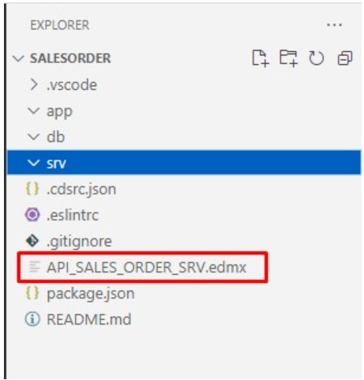

- Navigate to your project and run the below command, please refer this documentation for consuming the external services from CAP Application.
(Make sure that you are in root folder of your project)

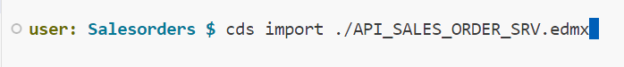

- Once you execute command, your edmx file will get moved to .src/external folder and API_SALES_ORDER_SRV.csn and API_SALES_ORDER_SRV.edmx file will get created.
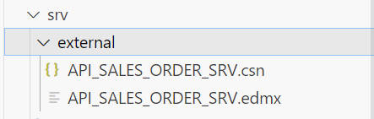

- Additionally, the file will be registered as service definition in the package.json file and the remote system we want to consume requires CSRF-Token Handling, so we enabled the new CSRF-token handling of @sap-cloud-sdk/core via configuration options: csrf: true/false and csrfInBatch: true/false. Refer this documentation for more details.
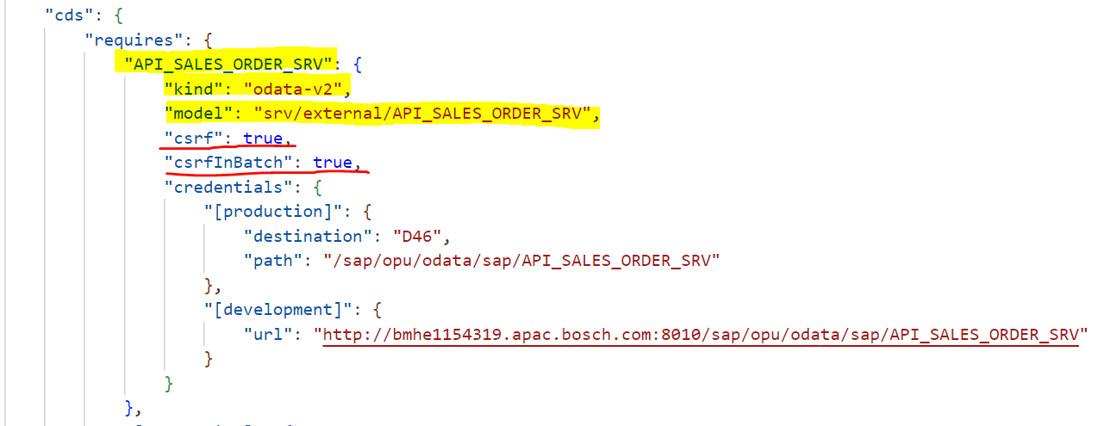

- Created 2 local entities SalesOrder & SalesOrderItem in db folder of cap application, these we created to have draft capabilities for Edit operation as we can’t build transactional cap application directly on external api(this is non-draft v2 service).
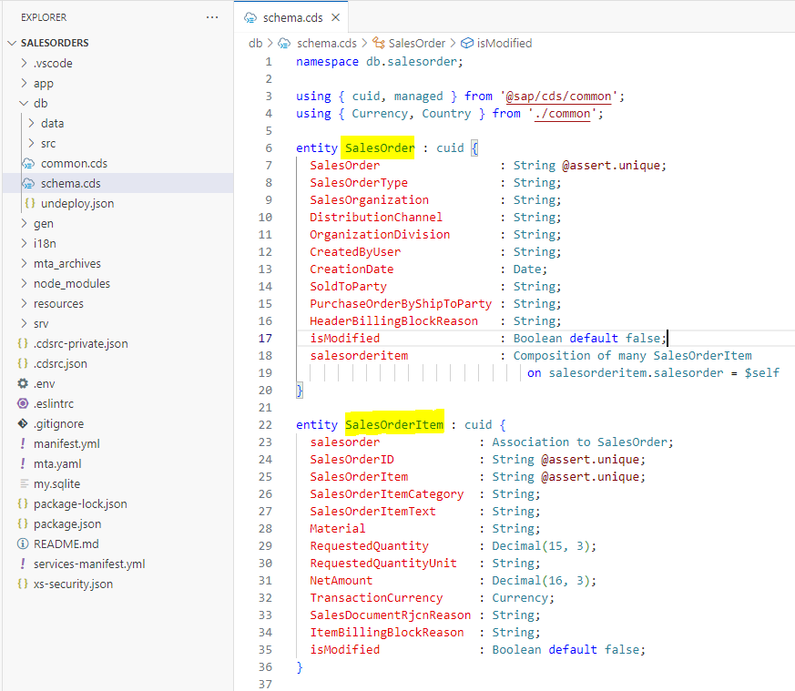

- Now expose the Sales Order through your service by adding following lines to your code in the srv/OrderService.cds file. (Yellow color highlighted entities are from External API and red color bordered ones are from local db entities).
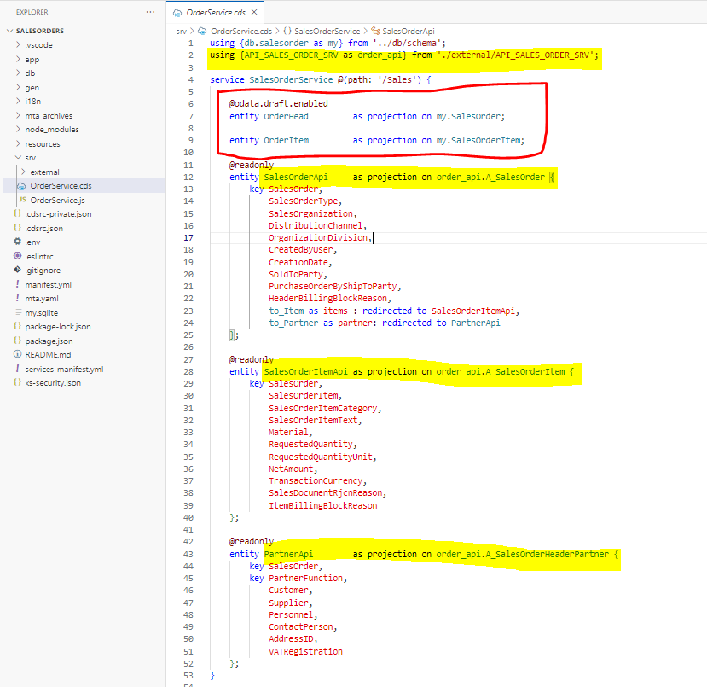
- If you want to mock the external service Install the below node packages.
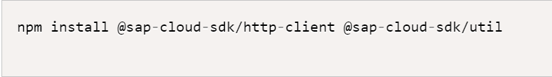

- Now let’s add the handlers code to fetch the sales data from D46 system using external api. ( Inside the srv folder create OrderService.js file which is default handler method for the OrderService.cds. Ensure that .js and .cds file name are same.)
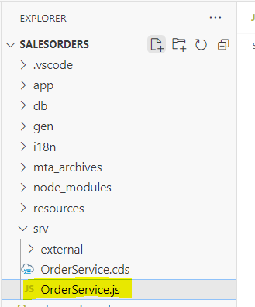

- As we want to make sales order field as mandatory selection filter to be entered by user in fiori app. When user clicks go after entering the value, we will make read request to external api to fetch the sales data and insert that data to our local entities.

In our scenario we will implement custom handler with Methods .on and with Argument event READ request on OrderHead. (Refer this documentation for event handlers).
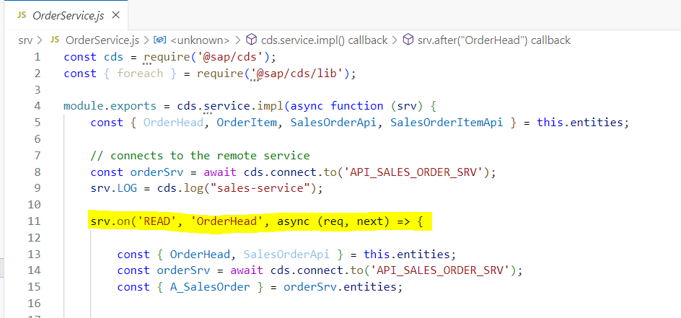

- In our custom event handler first, we are connecting to remote service using below line.
const orderSrv = await cds.connect.to('API_SALES_ORDER_SRV');

- Using this connection orderSrv, we are sending a GET request to D46 system to read the sales data with where condition, refer below code.
const result = await orderSrv.run(SELECT.from(A_SalesOrder, (so) => {
so.SalesOrder,
so.SalesOrderType,
so.SalesOrganization,
so.DistributionChannel,
so.OrganizationDivision,
so.CreatedByUser,
so.CreationDate,
so.SoldToParty,
so.HeaderBillingBlockReason,
so.to_Item((items) => {
items.SalesOrder,
items.SalesOrderItem,
items.SalesOrderItemCategory,
items.SalesOrderItemText,
items.Material,
items.RequestedQuantity,
items.RequestedQuantityUnit,
items.NetAmount,
items.TransactionCurrency,
items.SalesDocumentRjcnReason,
items.ItemBillingBlockReason
});
so.to_Partner((partner) => {
partner.SalesOrder,
partner.PartnerFunction,
partner.Customer,
partner.Supplier,
partner.Personnel,
partner.ContactPerson
});
}).limit(100).where(req.query.SELECT.where));

(In the above code we are also fetching the associated entities data like in our case getting the Item data(to_Item) and Partners data(to_Partner).)
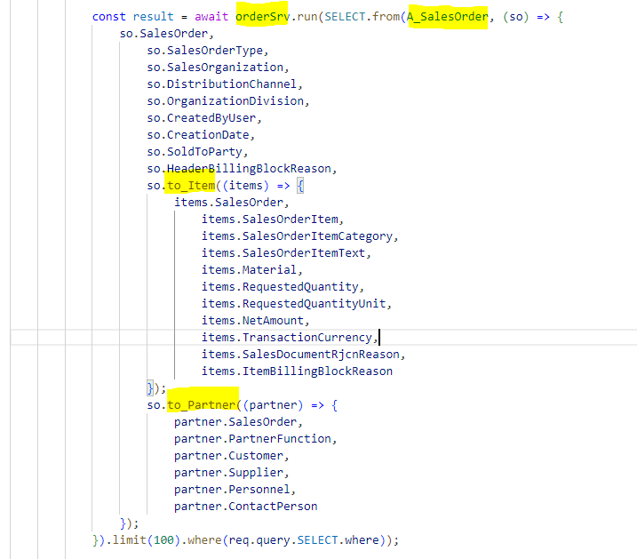

- Once the above read success we will have the requested sales data in const result. (Refer below screen shot).
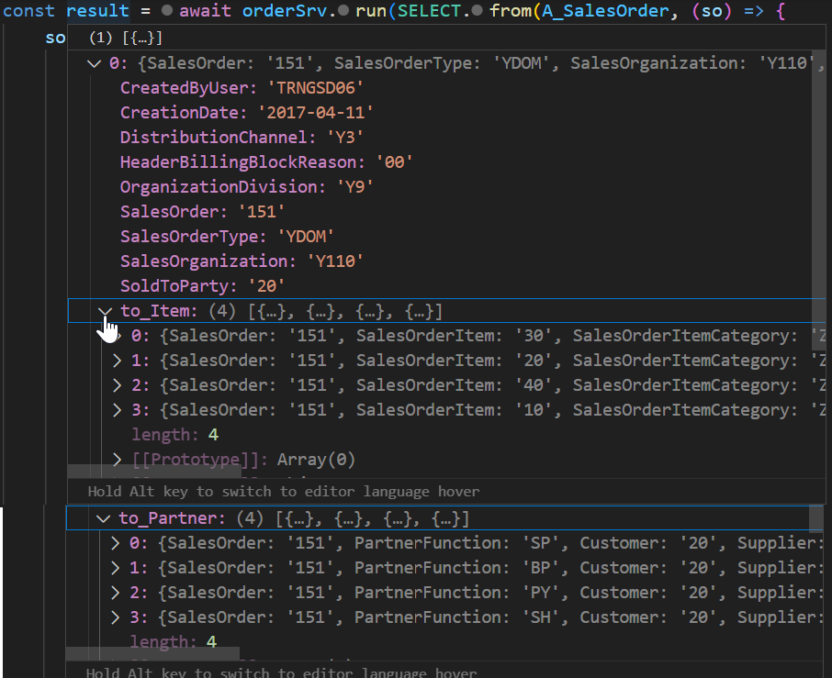
- As we now have the sales data available from the remote system (On-Prem), now fill this data to our local entities.
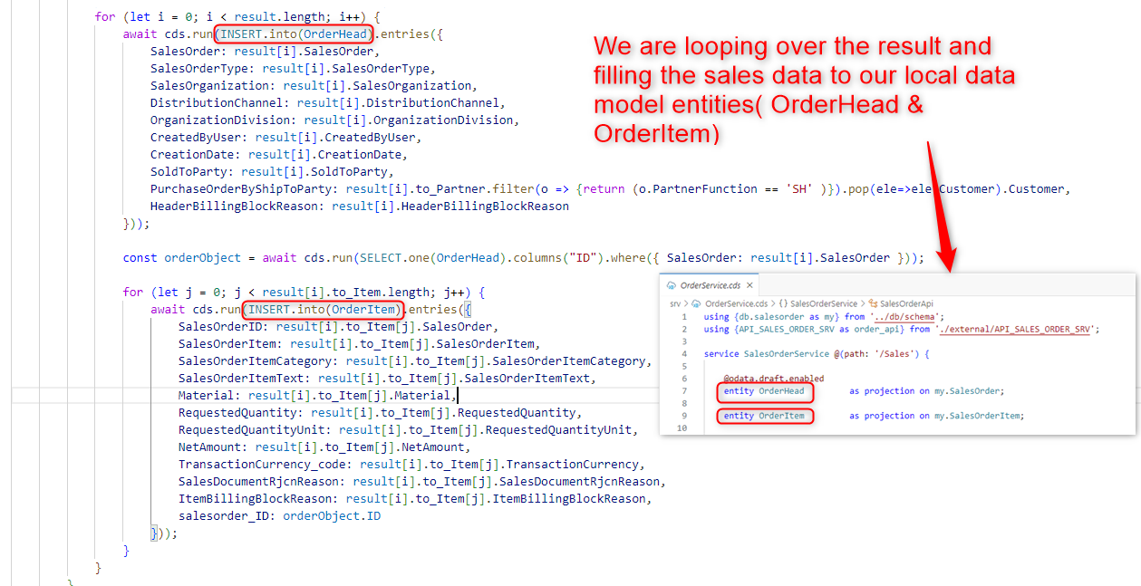

- Fiori Tile in Work Zone.
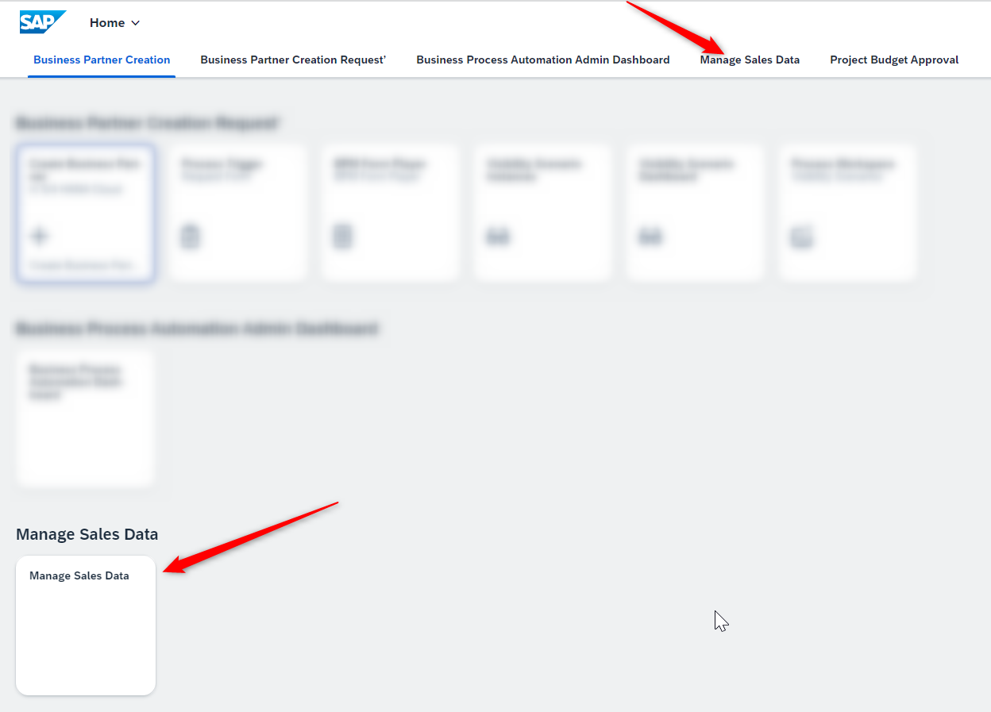

- The Fiori App looks like below, after entering the Sales Order Id in mandatory selection (by this time the data is visible in list page due to the logic we build in step no. 13).

List Page:
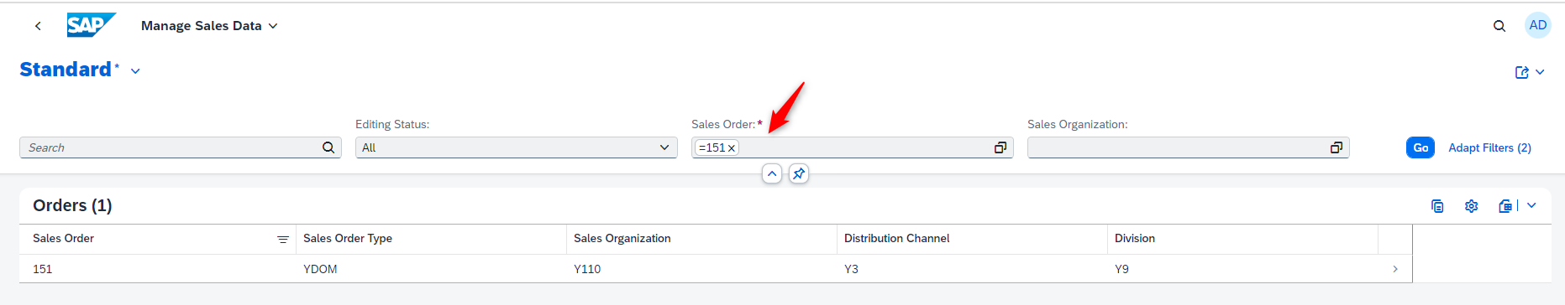
Object Page:
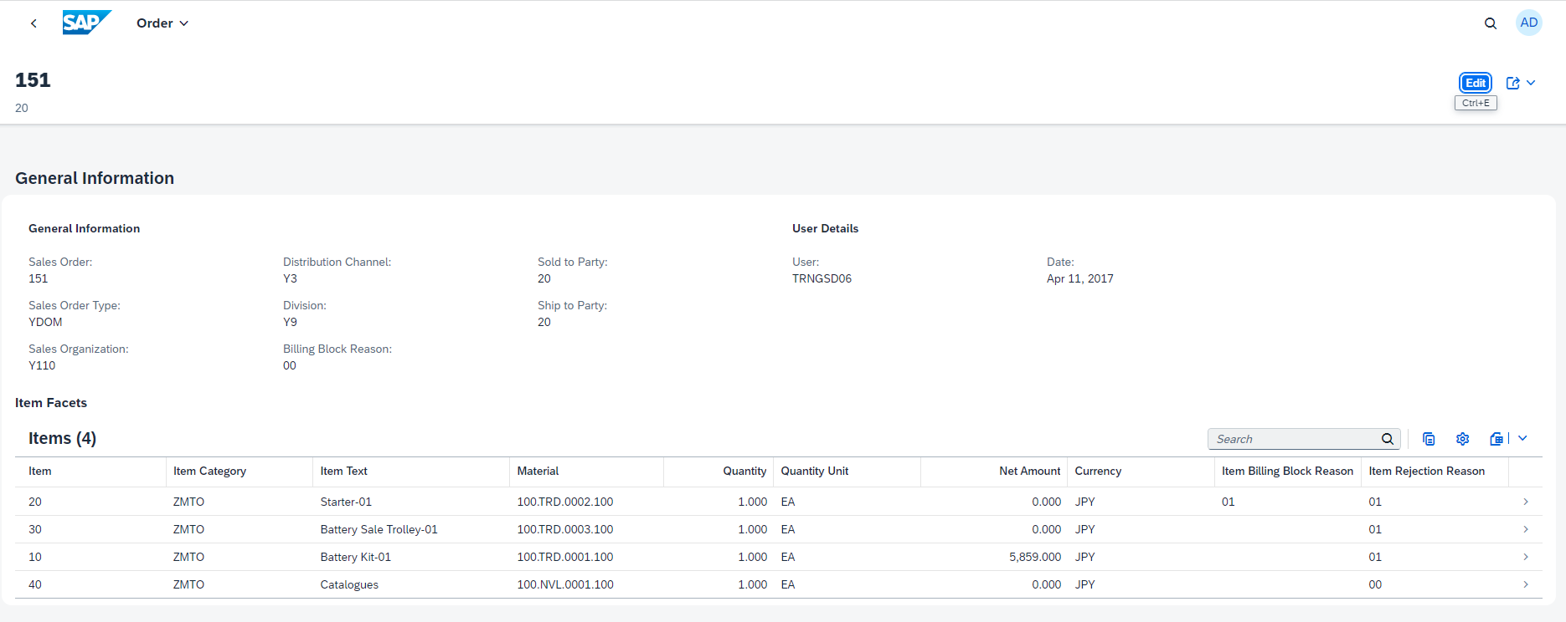

- Editing the data from object page by clicking on EDIT button(Only pointed fields are editable for now).
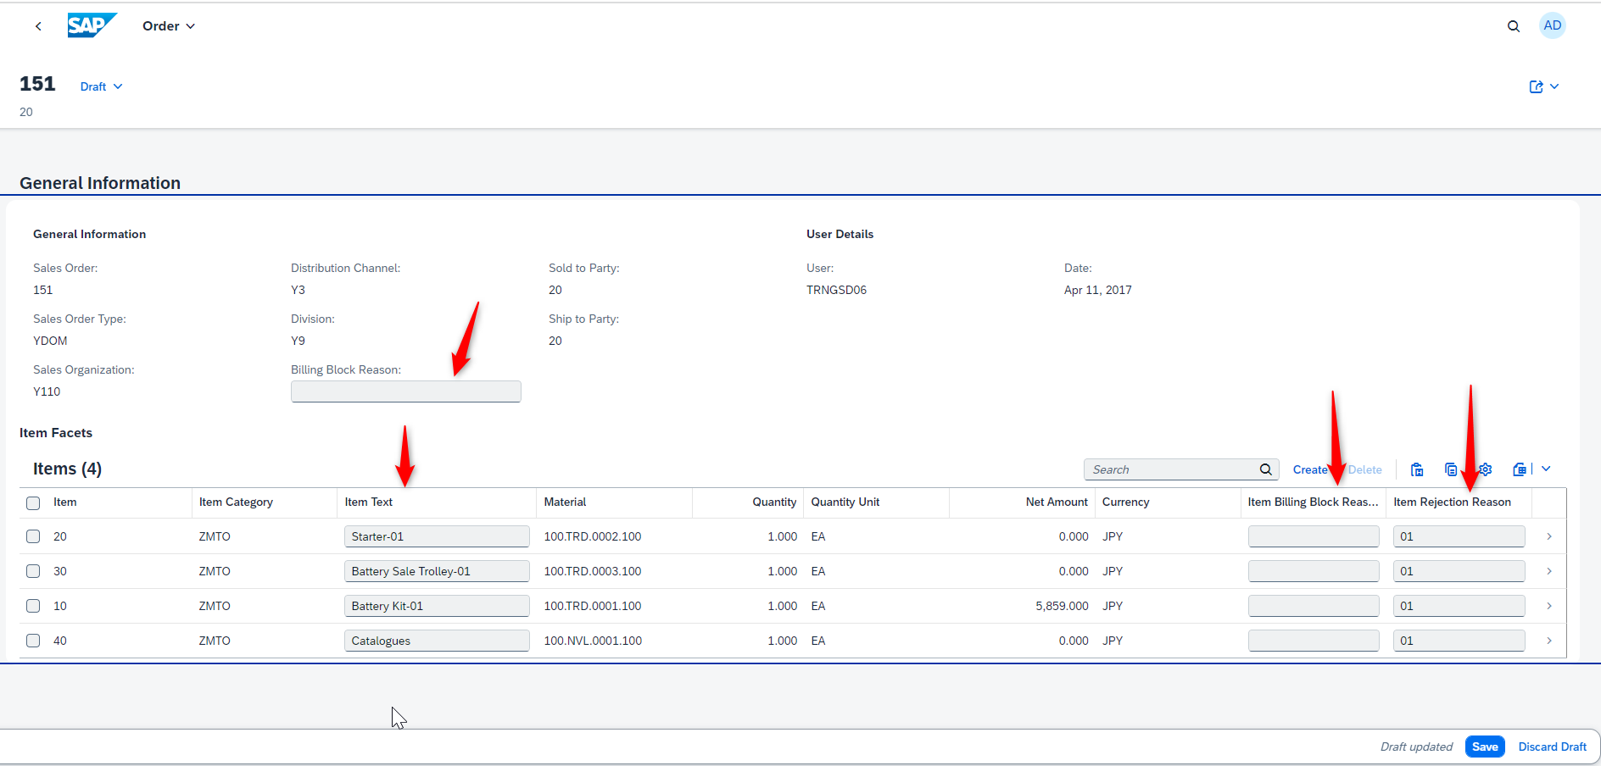

- Once the Update/Edit performed in object page when user clicks on Save button we want to send back these changes/Updates to On-Prem system as well, to implement this logic we created another custom handler with Methods .after and with Argument event UPDATE request on OrderHead.
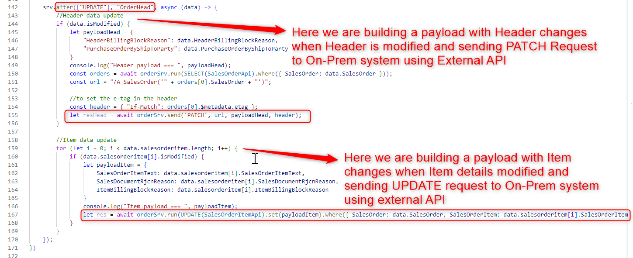

- The Data modification flag is setting on both Header and Item using the custom Handlers implementation, refer the below screen shot.
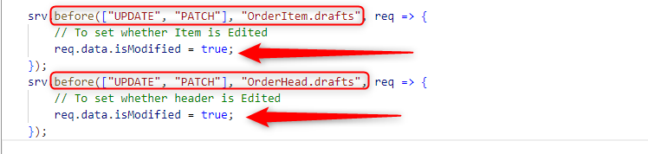

- With the above steps we were able to Build the CAP Application/Service to fetch the sales data from On-Prem system and Sending back Updates to On-Prem system using external API.

